**RideApp Acadguild Project**

**Synopsis**

**The project is designed to get taxis nearby and pay and goto your destination** 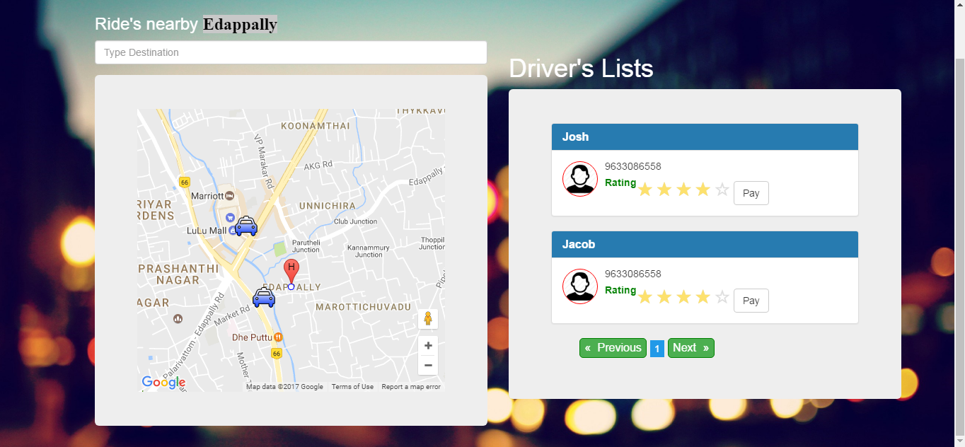

**Tools used**

* Have used angular2 cli to start project
* Have used angular2-google-maps for google map display.
* Have used ng2-rating for display rating.
* Have used ng2-pagination for pagination implementation of restaurant lists.